Exercise 2 : E-commerce Platform Search Function

What is Big O Notation?
Big O notation is a mathematical way to describe the efficiency of an algorithm as the input size increases. It focuses on the worst-case, average-case, and best-case performance, helping developers choose the most optimal algorithm for their needs.

Why Matters:
- Helps compare multiple algorithms
- Predicts scalability
- Guides optimization

For Search Operations:
Case | Linear Search | Binary Search
Best Case | O(1) (first item) | O(1) (middle item)
Average Case | O(n/2) | O(log n)
Worst Case | O(n) | O(log n)

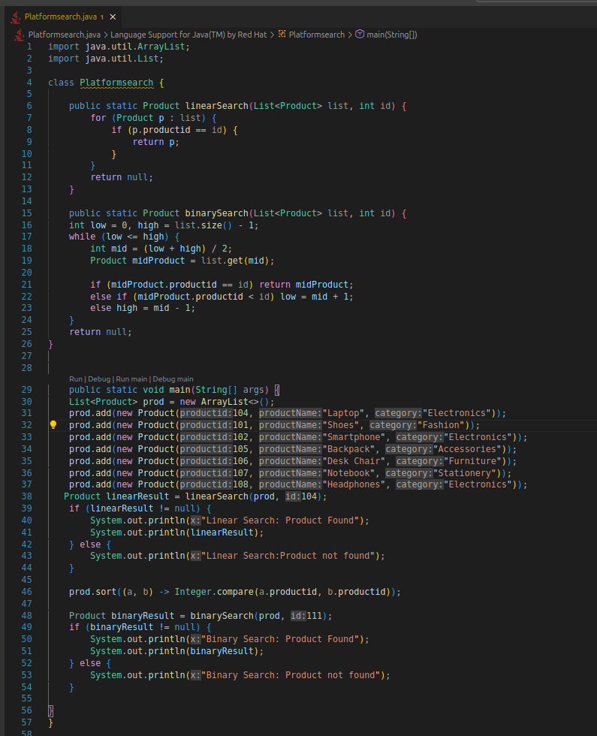
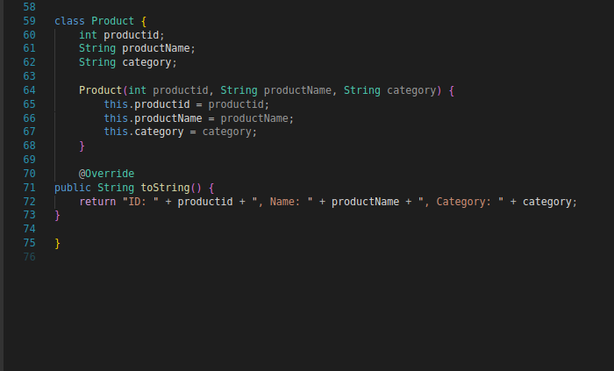
Output :
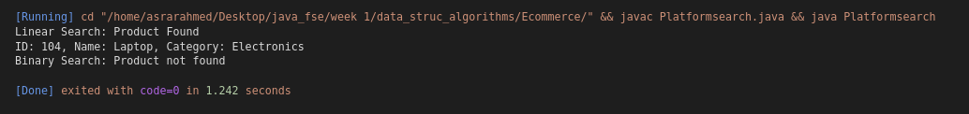

Algorithm Analysis

Linear Search
- Scans each item in the list one by one.
- When the data is unsorted or the list is small.
- Time Complexity:
  - Best: O(1)
  - Average: O(n/2)
  - Worst: O(n)

Binary Search
- Repeatedly divides a sorted list in half to locate the target.
- When the list is sorted and size is large.
- Time Complexity:
  - Best: O(1)
  - Average/Worst: O(log n)

For an optimized e-commerce search on product ID,binary search is more suitable but requires sorting .

